Program Efficacy Report

Electricity/Electronics

Submitted by Professor Ed Szumski
Department Head, Electricity/Electronics

March 2010
Program Efficacy, Spring 2010

Complete and attach this cover sheet as the first page of your report.

Program Being Evaluated
Electricity/Electronics

Name of Department:
Electricity/Electronic/Technical Calculations

Name of Division
Applied Technology, Transportation and Culinary Arts

Name of Person Preparing this Report Extension
Ed. Szumski 8501

Name of Department Members Consulted
Carlos M. (Buzz) Busselle

Name of Efficacy Team
Andre Wooten Ext. 8511; John Stanskas Ext. 8268

Program Review Committee Representatives
Guy Hinrichs; Richard Jaramillo

Work Flow | Due Date | Date Submitted
Date of initial meeting with department | March 1, 2010 | March 1, 2010
Final draft sent to the dean | March 26, 2010 | March 26, 2010
Report submitted to Program Review Team | April 1, 2010 | March 31, 2010
Meeting with Review Team | Click here to enter text. | Click here to enter text.

Staffing
List the number of full and part-time employees in your area.
Classification | Number Full-Time | Number Part-time, Contract | Number adjunct, short-term, hourly
Managers | 0 | 0 | 0
Faculty | 2 | 8 | 0
Classified Staff | 0 | 0 | 0
Total | 2 | 8 | 0

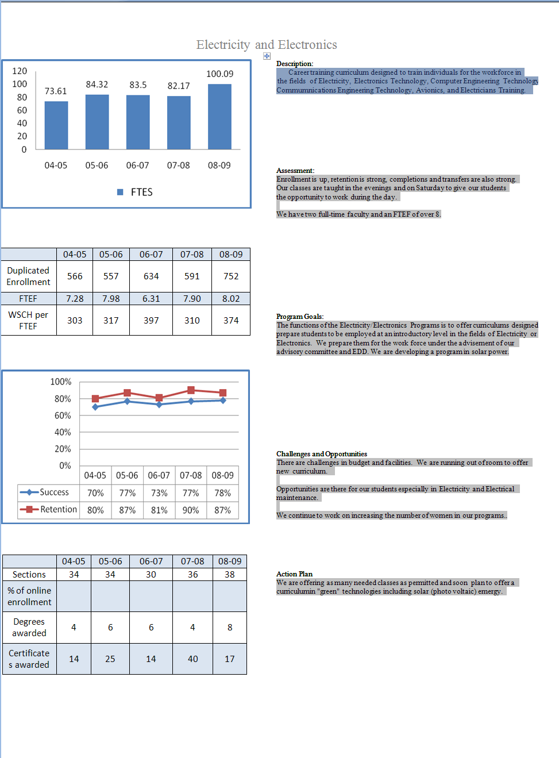
Part I. Questions Related to Strategic Initiative: Access

Use the demographic data provided to describe how well you are providing access to your program by answering the questions below.

Gender | Frequency | Dept. Pct. | Campus Pct.
Female | 247 | 9.7% | 58.5%
Male | 2291 | 90.0% | 40.5%
Total | 2546 | 100.0%
*Totals do not include respondents who did not identify gender.

Ethnicity | Frequency | Dept. Pct. | Campus Pct.
Blank | 3 | .1% | 1.47%
Asian | 177 | 7.0% | 4.58%
Black | 333 | 13.1% | 22.03%
Filipino | 53 | 2.1% | 1.93%
Hispanic | 1223 | 48.0% | 39.85%
Nat Amer | 17 | .7% | .99%
Other | 45 | 1.8% | 1.18%
Pac Islander | 6 | .2% | .75%
White | 616 | 24.2% | 24.55%
X-undeclared | 73 | 2.9% | 3.17%
Total | 2546 | 100.0% | 100.00%

Disability | Frequency | Dept. Pct. | Campus Pct.
Non-Disabled | 2499 | 98.2% | 95.5%
Disabled | 47 | 1.8% | 4.5%
Total | 2546 | 100.0% | 100%

Does the program population reflect the college’s population? Is this an issue of concern? If not, why not? If so, what steps are you taking to address the issue?

Analysis of the demographic data shows that, overall, our students in the Electrical/Electronics department courses reflect the composition of students on the San Bernardino Valley College campus. It is comprised of students with ethnically diverse backgrounds with the majority population of Hispanic ethnicity at about 8% above the general campus population. Black students are about 8% below the general campus population. The San Bernardino City Unified School District is a Hispanic-Serving School District (HSSD) and perhaps our student population reflects the percentage of students our department recruits from area high schools. The only major area of concern is the very low proportion female students. Almost all of the electrical/electronics occupations listed on the “Nontraditional Employment for Women” Civilian Labor Force by Occupation and Sex shows less than 25% of those occupations are held by women. The entries in BOLD show the occupations where women are less than 25% of the workforce (see report on the next page). We are highly committed to increasing female enrollment in our courses and programs. To address this issue nationally, a bill has been introduced in Congress on March 11, 2010, that addresses this inequality. H. R. 4830: To promote the economic self-sufficiency of low income women through their increased participation in high-wage, high demand occupations where they currently represent 25 percent or less of the workforce. SEC. 2 (7) FINDINGS “Women make up 95.6 percent of child care workers, whose hourly wage averages $9.79, but only 1 percent of electricians, who make an average hourly wage of $23.98” Over a lifetime, a woman makes $629,216 and an electrician makes $1,510,080. This is a $880,864 difference over a lifetime! Area employers are interested in balancing their workforces and are very interested in hiring our non-traditional students.

To address this issue locally, during this next three year period, my full-time and adjunct faculty members will attempt to partner with the Institute for Women in Trades, Technology & Science (IWITTS), Tradeswoman Inc., Nontraditional Careers Statewide Leadership Project – San Diego County Office of Education, and Women In Non-Traditional Employment Roles (WINTER), to help expand the horizons for women to enter our high-wage, high-skill professions. We seek mentors for our entry-level electrical/electronics students and we are going to elementary and middle schools (5th and 6th grades) to show young girls that they can succeed in traditional male employment positions. Since Science, Technology, Engineering and Math (STEM) are part of our curriculum, I’ll work with the STEM representatives to integrate our programs into their presentations.

Although we have very few disabled students, we do have strategies for physical accessibility to our classrooms. All doors are at least 36 inches wide. Lab tables and desks are at standard height and lab materials can be reached by someone in a wheelchair. Hearing impaired students can have copies of my board notes. I can make copies and/or send them .jpg pictures of the white boards in my classroom. Our DSPS office has worked with our department in the past with test accommodation and also they have provided our hearing impaired students with a captionist to record what I’ve said up in front of my class.

We also have incorporated strategies into our courses for the other “special population” students which include economically disadvantaged, single parent, and displaced homemaker students. These strategies include instructional support, tutoring, and career guidance which were suggested by the California Community College Special Populations Collaboration.

At least once each semester, I invite a major employer such as Southern California Edison to come into my Direct Current Circuits lecture classroom to talk about the many job opportunities available with their company.

Top 20 Industries Employing this Occupation in San Bernardino County
INDUSTRY TITLE | SOC Code | Total # | Need
Electricians (635) | 47-2111 | 6,780 | 12.80%
Electronic Equipment Installers and Repairers, Motor Vehicles (711) | 49-2096 | 310 | 12.90%
Security and Fire Alarm Systems Installers (713) | 49-2098 | 580 | 20.70%
Electrical Power-Line Installers and Repairers (741) | 49-9051 | 1,170 | 22.20%
Electronic Home Entertainment Equipment Installers and Repairers (712) | 49-2097 | No data | No data
Electric Motor, Power Tool, and Related Repairers (704) | 49-2092 | 210 | 0
Avionics Technicians (703) | 49-2091 | No data | No data
Telecommunications Line Installers and Repairers (742) | 49-9052 | 2,850 | 14%
Power Plant Operators, Distributors, and Dispatchers (860) | 51-8010 | No data | No data
Electrical and Electronics Engineers (141) | 17-2070 | 0 | 0
Electrical and Electronics Repairers, Industrial, Utility, and Transportation Equipment (710) | 49-209X | No data | No data
Miscellaneous Engineers, Including Agricultural and Biomedical (153) | 12-2031 | 3,100 | 32.3%
Broadcast and Sound Engineering Technicians and Radio Operators and Other Media and Communication Equipment Workers (290) | 27-40XX | No data | No data
Radio and Telecommunications Equipment Installers and Repairers (702) | 49-2020 | No data | No data
Radio Mechanics | 49-2021 | No data | No data
Telecommunications Equipment Workers, Except Line | 49-2022 | 1,450 | 17.20%
Engineering Technicians, Except Drafters (155) | 17-3020 | No data | No data
Computer Support Specialists (104) | 15-1041 | 3,250 | 18.50%
Electrical, Electronics, and Electromechanical Assemblers (772) | 51-2023 | 580 | 6.90%
Computer, Automated Teller, and Office Machine Repairers (701) | 49-2011 | 980 | 3.10%

Pattern of Service

How does the pattern of service and/or instruction provided by your department serve the needs of the community? Include as appropriate hours of operation/pattern of scheduling, alternate delivery methods, weekend instruction/service.

Hours of Operation/pattern of scheduling

Our classes are primarily taught in the late afternoon (3:30 p.m. or 4:30 p.m.) and evenings (6:00 p.m.) or on Saturday morning and afternoon. Our students can work in the electrical/electronics field as Electrician Trainees during the day and still complete their certificate requirements within four semesters. A special afternoon class (1:00 p.m.) was scheduled during the fall and spring semesters to fulfill a memorandum of understanding (MOU) with the San Bernardino City Schools administration. Their plan is to bus high school students here for college classes in electricity and/or electronics technology and sustainable energy fundamentals. Our department brochures contain a flowchart which shows the layout of courses in the proper order in which our students should enroll with the prerequisites having been met in the prior semester. This is something I wish I had when I was a student here at SBVC back in the early 1970’s. For our third and fourth semester classes, the pattern alternates between Friday and Saturday, Fall and Spring semesters.

Alternate Delivery Methods

There are two courses (ELECTR 230 and TECALC 087) that are planned to be taught in an on-line format during the 2010-2011 academic year.

Weekend instruction/services

Classes are also taught on Friday evenings and on Saturdays during the fall and spring semesters to help our students complete their certificate(s) within four semesters.

Shown here is an Education Plan (tentative) for completion for the courses necessary to sit for the California State General Electrician Certification examination. Courses are taught in the evenings or on Saturdays. The cost per college unit is currently $26.00 and classes begin the week of August 16, 2010. Start right now by visiting the SBVC web site www.valleycollege.edu and complete the Application for Admission today. Registration for Fall 2010 classes begins in April.

SAN BERNARDINO VALLEY COLLEGE

GENERAL ELECTRICIAN CERTIFICATION PROGRAM
SPRING 2010 - FALL 2011
SPRING 2010 | FALL 2010 | SPRING 2011 | FALL 2011
ELECTR 110 3 Units  Direct Current Circuit Analysis  Reference # Section 01  W 6:00 - 8:50 p.m.  ELECTR 111 1 Unit  Direct Current Circuits Lab  Reference # Section 01  W+Th 4:30 - 5:50 p.m.  OR  Reference # Section 02  Th 6:00 - 8:50 p.m.  TECALC 087 4 Units  Technical Calculations  Reference # Section 50  F 5:00 - 8:50 p.m.  ELECTR 265 4 Units  Digital Logic Design  Reference # Section 01  M+T 6:00 - 8:50 p.m. | ELECTR 115  Alternating Current  Circuit Analysis  (3)  ELECTR 116  Alternating Current  Circuit Laboratory  (1)  ELECTR 230  Semiconductor  Devices  (3)  ELEC 216  Introduction to  Industrial Electricity  (4) | ELECTR 235  Solid State  Circuit Analysis  (4)  ELEC 217  Industrial  Electricity  (4)  ELEC 218  Controlling  Industrial  Electricity  (4) | INSPEC 014  Advanced Construction  Inspection: National  Electrical Code  (3)  INSPEC 024  Community Relations for  Civil Service Employees  (3)  ELEC 090  OSHA Safety Course  (2)
12 Units | 11 Units | 12 Units | 8 Units

Part II: Questions Related to Strategic Initiative: Student Success
Provide a brief analysis of the data and narrative from the program’s Educational Master Plan (EMP) Summary and discuss what it reveals about your program.
Analysis of the shows that the student retention rate averages 85% with 90% for the high and 80% for the low. In the areas where there were dips in the student retention portion shows primarily the Certified Electricians who took one or two of our course(s) to complete their required hours of Continuing Education needed every three years. Our students are motivated to stay in our program because of our department policy of designing a course “Ed Plan” (on the previous page) so the students know which classes can be taken and meet the prerequisites of the classes for the following semester. Our students can finish any of our certificate programs in four semesters! Our entry-level courses Direct Current Circuit Analysis lecture and lab and Alternating Current Circuits lecture and lab are transferable to the University of California and the California State University in their Electrical Engineering programs.

Our electricity/electronics program does a very good job of training and retaining our students. The electricity/electronics program is growing due to the need for certified electricians and a great interest in solar (photovoltaic) panel installers. Certified electricians are also required to complete 32 hours of continuing education (CE) every three years and this will keep our program growing. Our students also need two Inspection classes (014 and 024) provided by other departments on campus and our new OSHA (ELEC 090) class. The number of certificates will increase because the student must complete the general electrician’s certificate to be allowed to sit for the statewide electrician certification examination.

The student success rate averages 75% with 78% for the high and 70% for the low. Our courses do have academic rigor because they are articulated with CSUs and UCs. We are awarding an average of 22 certificates per year and about 6 Associate Degrees per year.

Supplemental Data
Provide any additional information such as job market indicators, standards in the field or licensure rates that would help the committee to better understand how your program contributes to the success of your students.
Job market related to their majors or certificates: (resource: California Employment Development Department EDD) | There are jobs available in our local area. I’ll use the local (San Bernardino) labor statistics.  Typical median wages are $29.59 per hour.  Electrical Power-line Installers 22% increase  Power Plant Operator 19.4% increase  Electrical and Electronics Repairers 25.4% increase  Electricians 12.8% increase  Security & Fire Alarm installers 20.7% increase  Telecommunications Line installers 14.2% increase  Electrical/Electronics Industrial Equip 7% increase
Standards in the field | Standards of acceptance are stated in the National Electrical Code for all electrical circuitry, installation and their placement. Our students must also complete the ELEC 090 course, the OSHA 30-Hour Safety Standards for Construction and Industry and carry their authorization card on the job site. Our students who complete our solar fundamentals course must pass the North American Board of Certified Energy Practitioners (NABCEP) certification exam for work in the this industry. Students in our Communications Engineering Technology program will prepare to pass to Federal Communication Commission General Radiotelephone Operator License (GROL) examination.
Labor and other statistics (national, western states, regional) www.labormarketinfo.edd.ca.gov | Typical jobs require installing, testing, adjusting, repairing, and calibrating electrical equipment or cables in electrical power or distribution systems or subsystems. See the chart of electricity/electronics jobs in the local are on page 5 of this report.
Comparison colleges | We are one of six community colleges in all of southern California that teaches the “Whole” General Electrician Certification program.
Job Placement | There is no Job Placement data attached to the e-mail you sent me to complete this document. Typically, electrical contractors and area electrical businesses contact us and ask for student referrals. I ask the company for their e-mail and/or website address and I have our students e-mail a current resume to the company which then contacts each student about scheduling job interviews for jobs.
Licensure rates | Students are still in the pipeline and it will be after this Spring 2010 semester that we will begin to see electrician certification rates increase.
Advisory Committee Recommendations | Our advisory committee discussed the inclusion of adding some green courses (environmental and energy saving items) to our curriculum. Discussion included wind energy, solar panels and related technologies. Mr. Szumski is looking into the Residential Electrical Systems Integration (RESI) certification and how it works into our ELEC 216C course and will investigate these technologies and may incorporate some aspect of sustainable energy green technology information in some of our other courses. We are also looking into the emerging technology of RFID (Radio Frequency Identification) technologies which are widely used in warehousing and parts location and distribution for inclusion in our ELECTR 250C Radio Transmitters, Receivers and Antennas class. Members attending the Aeronautics Advisory committee meetings have recommended training avionics specialists since most of the analog circuitry associated with “old” technology is being replaced by the newest digital “Fly-by-wire” technology.

Supplemental Information

Our Electricity/Electronics program offers five Associate of Science degrees. They are Electronics Technology, Communications Engineering Technology, Computer Engineering Technology, Electric Power Technology, and Avionics Technology. We offer six Certificates and they are Electronics Technology, Communications Engineering Technology, Computer Engineering Technology, Electric Power Technology, Avionics Technology, and the newest and fastest growing certificate the General Electrician Certification.

Certificate requirements are evaluated and driven by our Electricity/Electronics advisory committee. Our department has been an authorized testing site for the International Association of Radio, Telecommunications and Electromagnetics (iNARTE) for the past twenty-four years. In the past three years, twenty students have passed the Federal Communications Commission General Radiotelephone Operator License (GROL) Element 1 examination and sixteen have passed the element 3 examination. I am authorized to teach the Occupational Safety and Health Administration (OSHA) 10-hour and 30-hour OSHA Standards for the Construction Industry and can award completion cards to the class participants. We have worked closely with the Electrical Certification Curriculum Committee (ECCC) in Sacramento for the past seven years to "crosswalk" (their word, not mine) our electrical/electronics curriculum with the requirements for training of "Electrical Trainees" per AB1087 (Calderon) requirements which basically states that all electricians working for a C-10 contractor must pass a California state electrical certification exam or be enrolled in an approved program of instruction by an "Educational Provider". SBVC is listed on the Division of Apprenticeship Services (DAS) website as an approved "Educational Provider #117" for a whole program of electrician certification. We are one of only two community colleges in all of the Inland Empire and only there are only six in southern California that offers a whole program. Electricians who have not passed the state electrician certification exam and are not enrolled in an approved course of instruction will not be permitted to work as an electrician and certified electricians must also successfully complete 32 hours of continuing education every three years. We meet on a regular basis with the International Brotherhood of Electrical Workers (IBEW) and offer our programs to assist with the training of their electricians.

Our local advisory committee has recommended that expand our electricity/electronics courses to include sustainable “Green” technologies. The market for solar installers is increasing 40% annually according to the Solar Energy Industries Association (SEIA). This first year we will focus on solar energy generation. We have ordered the solar (photovoltaic) panels, and the supporting equipment to mount and test this solar energy generation method. Members attending the Aeronautics Advisory committee meetings have recommended training avionics specialists since most of the analog circuitry associated with “old” technology is being replaced by the newest digital “Fly-by-Wire” technology.
Student Learning Outcomes
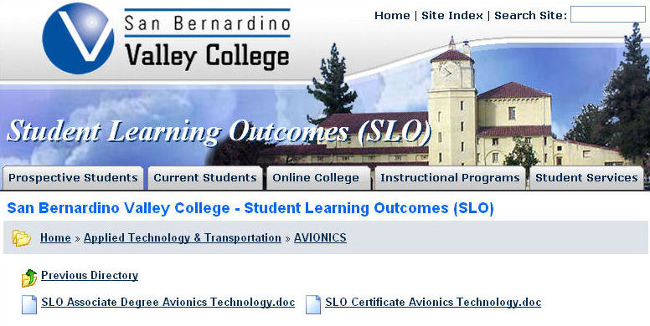
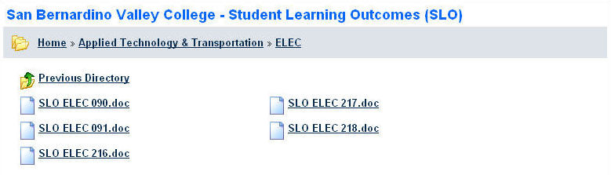
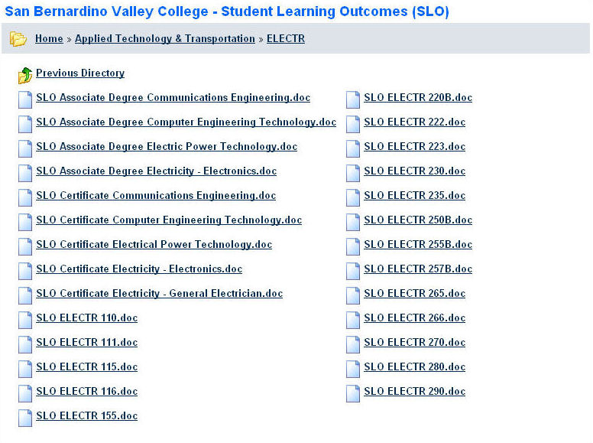

If you have courses for which SLOs have not been developed, explain why. What are your plans to remedy this?

All of our Electricity and Electronics Courses, Certificates, and Degrees have Student Learning Outcomes (SLOs) developed and are on file in the San Bernardino Valley College Instruction Office and in our division. We have analyzed assessment results from all of these SLOs and determined that no changes are currently required. I worked with our Instruction office to update the list (current list is shown) on the previous page which now shows all of our courses, certificates, and degrees.

Attach your three-year plan for assessing SLOs.

What progress has the program made in its three-year plan? Have you implemented any program changes based on assessment results?

Our department has completed assessment of two thirds of our courses, certificates, and degrees and is on track to complete the assessment of the remaining courses, certificates and degrees. We have completed an analysis of the assessment results (see chart) and has determined that there are no improvement changes needed to be made this cycle.

SLO STATUS CHECKLIST
Electricity/Electronics/Technical Calculations
 | DEGREE | DEGREE NAME | Defined  Expected  SLOs | Defined  Assessment  of SLOs | SLOs  Assessed | Data  Analyzed | Date Used for  Improvement
 | AS | Electronics Technology | X | X | F -08 | X
 | AS | Communication Engineering Technology | X | X | F-10
 | AS | Computer Engineering Technology | X | X | F -08 | X
 | AS | Electric Power Technology | X | X | F -08 | X
 | AS | Avionics Technology | X | X | F-10
 |  | CERTIFICATE NAME | Defined  Expected  SLOs | Defined  Assessment  of SLOs | SLOs  Assessed | Data  Analyzed | Date Used for  Improvement
 |  | Electronics Technology | X | X | F-08 | X
 |  | Communication Engineering Technology | X | X | F-10
 |  | Computer Engineering Technology | X | X | F-08 | X
 |  | Electric Power Technology | X | X | F-08 | X
 |  | Avionics Technology | X | X | F-10
 |  | General Electrician | X | X | F-09 | X
 | COURSE | COURSE NAME | Defined  Expected  SLOs | Defined  Assessment  of SLOs | SLOs  Assessed | Data  Analyzed | Date Used for  Improvement
 | ELEC-216C | Introduction to Industrial Electricity | X | X | F-08 | X
 | ELEC-217C | Industrial Electricity | X | X | F-08 | X
 | ELEC-218C | Controlling Industrial Electricity | X | X | F-10
 | ELECTR-110 | Direct Current Circuit Analysis | X | X | F-08 | X
 | ELECTR-111 | Direct Current Circuit Laboratory | X | X | F-08 | X
 | ELECTR-115 | Alternating Current Circuit Analysis | X | X | F-08 | X
 | ELECTR-116 | Alternating Current Circuit Laboratory | X | X | F-08 | X
 | ELECTR-155 | Electronic Drawing and Assembly | X | X | F-10
 | ELECTR 198 | Electronics Work Experience
 | ELECTR-220C | F.C.C. Rules and Regulations | X | X | F-09 | X
 | ELECTR-222 | Special Problems in Electronics I | X | X |  |  | Course  Deleted
 | ELECTR-223 | Special Problems in Electronics II | X | X |  |  | Course  Deleted
 | ELECTR-230 | Semiconductor Devices | X | X | F-08 | X
 | ELECTR-235 | Solid State Circuit Analysis | X | X | F-09 | X
 | ELECTR-250C | Radio Transmitters, Receivers, and Antennas | X | X | F-10
 | ELECTR-255C | Telephone Networking | X | X | F-09 | X
 | ELECTR-257C | Navigation and Communication Systems | X | X | F-10
 | ELECTR-265 | Digital Logic Design | X | X | F-08 | X
 | ELECTR-266 | Microprocessor Technology | X | X | F-08 | X
 | ELECTR-270 | Linear Integrated Circuit Analysis | X | X | F-10
 | ELECTR-280C | Mini Computer Operation and Maintenance | X | X | F-10
 | ELECTR-290C | Industrial Computers and Robotics Maintenance | X | X | F-10
 | TECALC-087 | Technical Calculations | X | X | F-08 | X
Part III. Questions Related to Strategic Initiative: Institutional Effectiveness
Mission and Purpose
What is the purpose of the program?
The purpose of the Electricity/Electronics Department is to offer curriculums designed to prepare students to be employed at an introductory level in the fields of Electricity and/or Electronics. The curriculum consists of Electronics Technology, Communications Engineering Technology, Computer Engineering Technology, Avionics Technology, Electrical Power Technology, and the General Electrician Certification Program. Our curriculum is recognized and sanctioned by the International Association for Radio, Telecommunications and Electromagnetics (iNARTE) and our graduates are eligible for membership in this organization and can join with a Junior Technician Certification. Our Avionics curriculum is recognized by the Aircraft Electronics Association. We prepare our students for the work force under the advisement of our advisory committee and the employment needs as reflected by the Electrical Certification Curriculum Committee (ECCC), the Division of Apprenticeship Standards (DAS), the Employment Development Department (EDD) of California and the Occupational Health and Safety Administration (OSHA). Our department is also actively engaged with our local high schools (Colton High School and San Bernardino City Schools) which have programs that articulate with our programs, and community and state electrical/electronics organizations to advance the state and region's economic growth and global competitiveness. We also prepare students to transfer to a number of public and private universities for further study in the various fields of Engineering and Industrial Technology.

How does this purpose relate to the college mission?
The electricity/electronics department mission is the same as the college mission. We want our diverse community of learners to succeed! We provide our students a hands-on learning experience to accompany their ability to understand theory, the ability to think critically, and the capacity to apply that knowledge in a real-world setting. Our students do very well because we provide our diverse student population with quality training, skills and knowledge necessary to succeed in business, industry, and their chosen professions in a multicultural society. We have plans to increase the number of women coming into our electricity/electronic programs by attending career day activities at area middle schools to speak to those female students and show them that women can be technicians and engineers. I have posters, brochures, and DVD presentations that I’ve purchased from The Institute for Women In Trades, Technology and Science (IWITTS) to show and share with these future technology and engineering students.

Productivity
Provide additional analysis and explanation of the productivity data and narrative in the EMP Summary, if needed.
Analysis of the productivity data shows that the electricity/electronics program has excellent enrollment and provides the training needed by the students who transfer to engineering or engineering technology programs at electrical contractors and others who hire our students. Enrollment is up, retention is strong, completions and transfers are also strong. In the past 5 years, there has been a significant increase in FTES. The increase from 04-05 to 05-06 is 14.55% and the increase in FTES from 04-05 to 08-09 is an increase of 36%!! There was a very slight decrease (only 1%) in the 06-07 academic year and we in the department are not certain what the reason is. There was also a very slight decrease (1.6%) the 07-08 academic year due to the management mandated reduction in class offerings during that time. Last year classes in our department generated over 100 FTES.

Our productivity in relation to the Full-Time Equivalent Faculty has averaged 7.5 FTEF for the past 5 years. Last year our FTEF was 8.02. Over 8 faculty members! We need to hire two new full time faculty members.

Our Weekly Student Contact Hours (WSCH) are below the college average due to laboratory equipment limitations and student safety concerns.

Relevance and Currency, Articulation of Curriculum
If applicable to your area, describe your curriculum by answering the following questions.
Applied Technology, Transportation & Culinary Arts
Electricity/Electronics
 | Course | Status | Last Content Review | Next Review Date
 | ELEC012 Utility Pole Climbing: OSPCTP | Active | 03/03/2008 | 03/03/2014
 | ELEC012 Utility Pole Climbing: OSPCTP | Historical | 08/17/2000 | 08/17/2006
 | TECALC087 Technical Calculations | Historical | 11/15/2004 | 11/15/2010
 | TECALC087 Technical Calculations | Active | 03/03/2008 | 03/03/2014
 | TECALC087 Technical Calculations | Historical | 11/15/2004 | 11/15/2010
 | ELEC090 OSHA 30-Hour Safety Standards: Construction and Industry | Active | 10/27/2009 | 10/27/2015
 | ELEC091 Fundamentals of Solar Energy | Active | 12/07/2009 | 12/07/2015
 | TECALC097 Technical Calculations | Historical | 04/15/2002 | 04/15/2008
 | TECALC097 Technical Calculations | Historical | 11/09/2009 | 11/09/2015
 | ELECTR098 Electronics Work Experience | Active | 11/23/2009 | 11/23/2015
 | ELECTR110 Direct Current Circuit Analysis | Active | 02/25/2008 | 02/25/2014
 | ELECTR110 Direct Current Circuit Analysis | Historical | 11/15/2001 | 11/15/2007
 | ELECTR110 Direct Current Circuit Analysis | Historical | 11/15/2001 | 11/15/2007
 | ELECTR111 Direct Current Circuit Laboratory | Historical | 11/15/2001 | 11/15/2007
 | ELECTR111 Direct Current Circuit Laboratory | Historical | 11/15/2001 | 11/15/2007
 | ELECTR111 Direct Current Circuit Laboratory | Active | 03/03/2008 | 03/03/2014
 | ELECTR115 Alternating Current Circuit Analysis | Historical | 11/15/2001 | 11/15/2007
 | ELECTR115 Alternating Current Circuit Analysis | Historical | 11/15/2001 | 11/15/2007
 | ELECTR115 Alternating Current Circuit Analysis | Active | 03/03/2008 | 03/03/2014
 | ELECTR116 Alternating Current Circuit Laboratory | Historical | 11/15/2001 | 11/15/2007
 | ELECTR116 Alternating Current Circuit Laboratory | Active | 03/03/2008 | 03/03/2014
 | ELECTR116 Alternating Current Circuit Laboratory | Historical | 11/15/2001 | 11/15/2007
 | ELECTR155 Electronic Drawing & Assembly | Historical | 08/01/2000 | 08/01/2006
 | ELECTR155 Electronic Drawing and Assembly | Active | 03/03/2008 | 03/03/2014
 | ELECTR158 Microcomputer Operation | Historical | 11/01/1999 | 11/01/2005
 | ELECTR158 Microcomputer Operation | Historical | 03/23/2009 | 03/23/2015
 | ELEC216B Introduction to Industrial Electricity | Historical | 12/12/2005 | 12/12/2011
 | ELEC216B Introduction to Industrial Electricity | Historical | 12/12/2005 | 12/12/2011
 | ELEC216C Introduction to Industrial Electricity | Active | 02/25/2008 | 02/25/2014
 | ELEC217B Industrial Electricity | Historical | 11/15/2004 | 11/15/2010
 | ELEC217B Industrial Electricity | Historical | 11/15/2004 | 11/15/2010
 | ELEC217C Industrial Electricity | Active | 02/25/2008 | 02/25/2014
 | ELEC218B Controlling Industrial Electricity | Historical | 11/15/2004 | 11/15/2010
 | ELEC218B Controlling Industrial Electricity | Historical | 11/15/2004 | 11/15/2010
 | ELEC218C Controlling Industrial Electricity | Active | 02/25/2008 | 02/25/2014
 | ELECTR220B FCC Rules and Regulations | Historical | 11/15/2004 | 11/15/2010
 | ELECTR220C FCC Rules and Regulations | Active | 09/22/2008 | 09/22/2014
 | ELECTR222 Special Problems in | Historical | 08/17/2000 | 08/17/2006
 | ELECTR222 Independent Study in Electronics | Historical | 10/26/2009 | 10/26/2015
 | ELECTR223 Special Problems in | Historical | 08/17/2000 | 08/17/2006
 | ELECTR223 Special Problems in Electronics II | Historical | 10/26/2009 | 10/26/2015
 | ELECTR230 Semiconductor Devices | Active | 02/26/2007 | 02/26/2013
 | ELECTR230 Semiconductor Devices | Historical | 08/17/2000 | 08/17/2006
 | ELECTR235 Solid State Circuit Analysis | Historical | 08/01/2001 | 08/01/2007
 | ELECTR235 Solid State Circuit Analysis | Active | 03/03/2008 | 03/03/2014
 | ELECTR235 Solid State Circuit Analysis | Historical | 08/01/2001 | 08/01/2007
 | ELECTR250B Radio Transmitters, Receivers and Antennas | Historical | 11/15/2004 | 11/15/2010
 | ELECTR250C Radio Transmitters, Receivers and Antennas | Active | 09/22/2008 | 09/22/2014
 | ELECTR255B Telephone and Data Networking | Historical | 11/15/2004 | 11/15/2010
 | ELECTR255C Telephone and Data Networking | Active | 09/22/2008 | 09/22/2014
 | ELECTR257B Navigation & Communication Systems | Historical | 11/15/2004 | 11/15/2010
 | ELECTR257C Navigation and Communication Systems | Active | 09/22/2008 | 09/22/2014
 | ELECTR265 Digital Logic Design | Historical | 04/15/2002 | 04/15/2008
 | ELECTR265 Digital Logic Design | Historical | 04/15/2002 | 04/15/2008
 | ELECTR265 Digital Logic Design | Active | 09/22/2008 | 09/22/2014
 | ELECTR266 Microprocessor Technology with Assembly Language | Active | 09/22/2008 | 09/22/2014
 | ELECTR266 Microprocessor Technology | Historical | 11/15/2001 | 11/15/2007
 | ELECTR270 Linear Integrated Circuit | Historical | 01/10/2002 | 01/10/2008
 | ELECTR270 Linear Integrated Circuit Analysis | Active | 09/22/2008 | 09/22/2014
 | ELECTR280B Mini Computer Operation and Maintenance | Historical | 11/15/2004 | 11/15/2010
 | ELECTR280C Computer Operation and Maintenance | Active | 09/22/2008 | 09/22/2014
 | ELECTR290B Industrial Computers and Robotics Maintenance | Historical | 11/15/2004 | 11/15/2010
 | ELECTR290C Industrial Computers and Robotics Maintenance | Active | 09/22/2008 | 09/22/2014
 | TECALC950 Shop Calculations | Historical | 11/10/2008 | 11/10/2014
 | TECALC950 Shop Calculations | Historical | 04/15/2002 | 04/15/2008

The Content Review Summary from Curricunet indicates the programs current curriculum status. If curriculum is out of date, explain the circumstances surrounding the error and plans to remedy the discrepancy.
The Content Review Summary from Curricunet listed above is correct as printed with one exception. ELEC 012 shows Active, but it is in a Course Deletion status and should not appear in the next college catalog. All other courses marked Historical have been superseded or deleted.
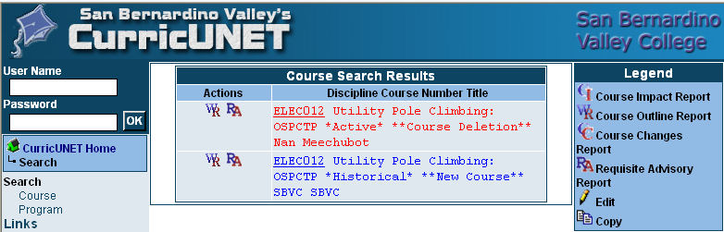

Articulation
List Courses above 100 where articulation is not occurring | With California State University | With University of California
 | All of our ELEC and ELECTR courses numbered 100 and above are articulated and transfer to CSU for college credit. | Our ELECTR 110, 111, 115, and 116 courses are articulated for transfer to the UC Electrical Engineering Program. All other coursework in that UC Electrical Engineering Program is considered upper division and our courses will not articulate for transfer.

Describe your plan to articulate these classes.
I will be attending the Engineering Liaison Council (ELC) meeting during the third week in March 2010. The Engineering Liaison Council is an organization composed of representatives of engineering and engineering technology education throughout California and several other states.

The representatives are from colleges of engineering of the UCs, CSUs, private universities and California Community Colleges. The ELC is dedicated to strengthening and improving the quality of engineering education; it has been serving a very important and critical function in engineering education since 1947. The ELC continues to work on improving articulation between two- and four-year programs of engineering and engineering technology; ensuring uniformity of basic concepts in core courses; establishing up-to-date and accurate guidance information; and collecting statistics pertaining to the numbers of incoming and completing engineering majors.

I will meet with representatives from the CSUs and UCs to begin a dialog on articulating our two new courses. Our new Solar Energy Fundamentals course (ELEC 091) and the Occupational Safety and Health Administration (OSHA) 30-Hour Safety Standards: Construction and Industry course (ELEC 090).

Currency
Review the last college catalogue data given below.
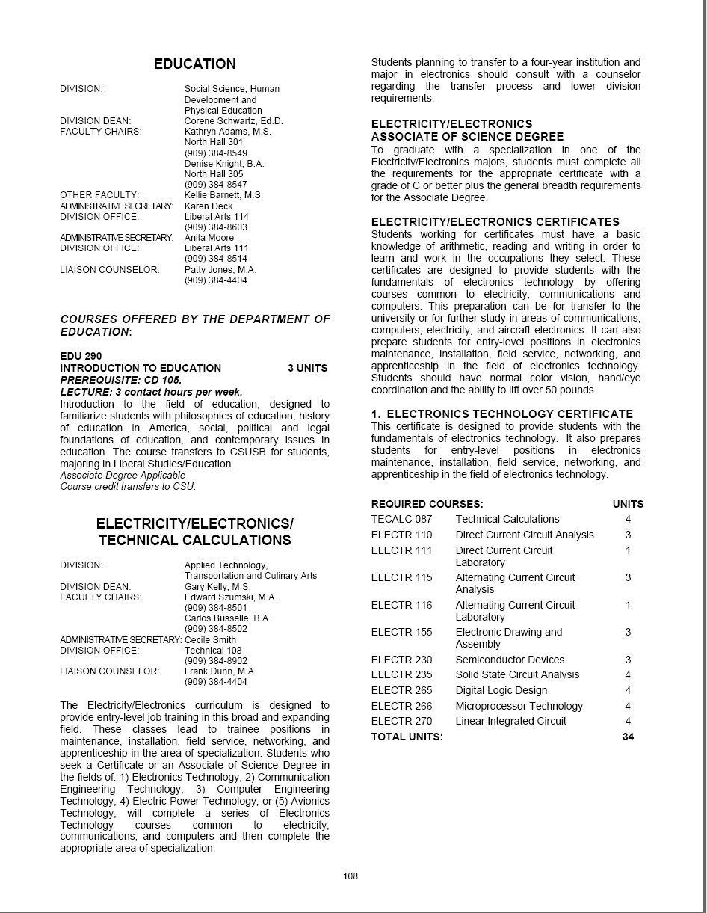
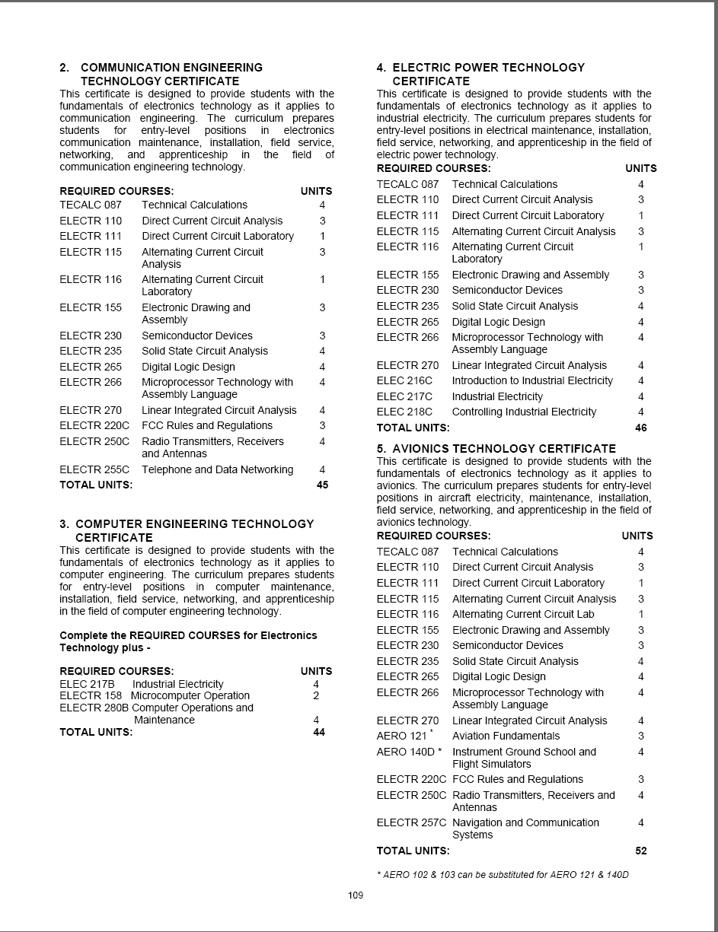
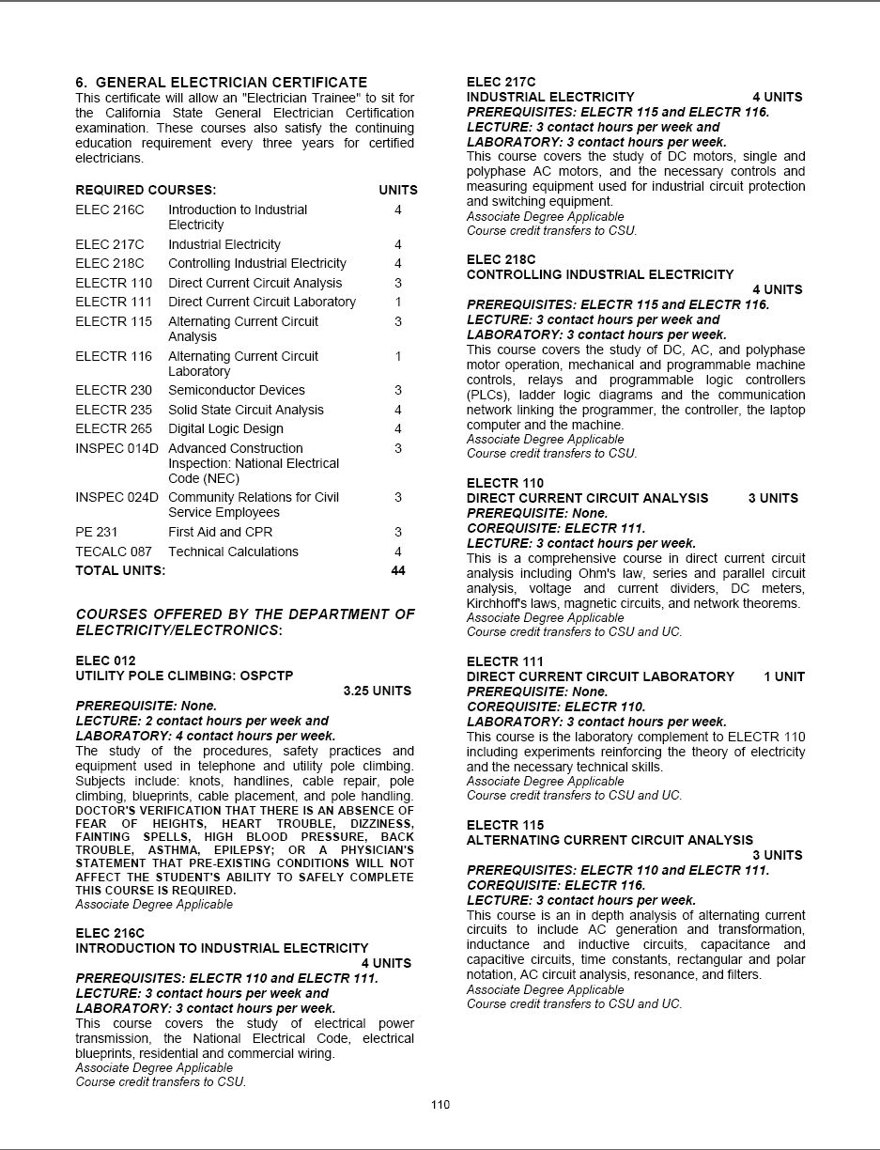
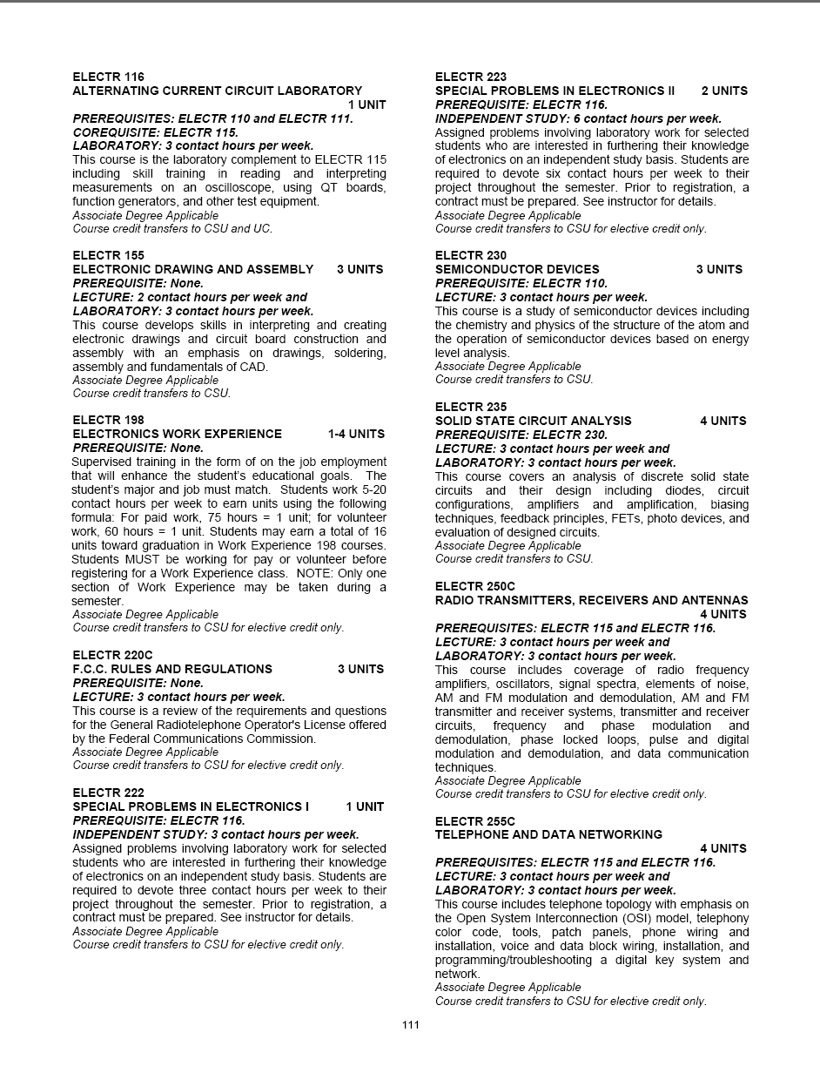
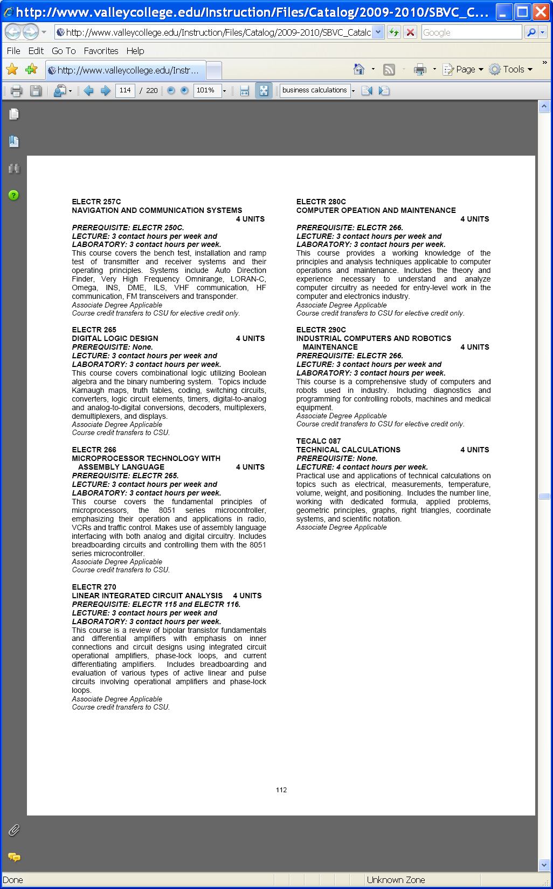
Which courses are no longer being offered? (Include Course # and Title of the Course)
ELEC 012 Utility Pole Climbing: OSPCTP - Course deletion in progress – See page 18 at bottom
ELECTR 222 Special Problems in Electronics ! - Course deletion in progress – Curricunet shows this course in “Historical” status
ELECTR 223 Special Problems in Electronics !I - Course deletion in progress – Curricunet shows this course in “Historical” status
Planning
What are the trends, external to the institution, impacting your student enrollment/service utilization? How will these trends impact program planning?
Trends include increased use of solar (photovoltaic) energy systems and the need for certified solar installers. Governor Schwarzenegger signed SB-1, the “One Million Solar Roofs” initiative in 2007 and wants 1,000,000 roofs with solar panels installed in the next 6.5 years. That’s 150,000 roofs per year and an estimated need of 10,000 new installer jobs. Also the emerging technology of RFID (Radio Frequency Identification) uses in all warehouses to control assets. RFID will also be used in humans with the insertion of an RFID chip that contains emergency medical information and quite possibly your financial data according to information I’ve read from the Institute of Electrical and Electronic Engineers (IEEE). More new trends include new Avionics Systems using digital “Fly-by-Wire” technologies to replace older analog systems (Avionics Magazine, January 2010 and Avionics News Magazine, November 2009).

We are running out of laboratory space and we need more room to expand our solar (photovoltaic) installation program. We’ll need at least 400 square feet when we receive all of the ordered photovoltaic (solar) panels, the grid-tied inverter to connect the panels to the power grid, and the roof supporting installation equipment and parts.

I see only expansion in our program due to the statewide solar initiative and the required electrician certification that was enacted three years ago. Plus any new emerging technology such as RFID. Fiber Optic installers are still in demand (OSP Magazine, June 2009), with most cable/telephone companies installing fiber to the house (FTTH). Verizon’s FIOS is this type of fiber optic connection. Even in a lagging economy, there is still a need for our students to fill vacant positions of employment in this era of depleted budgets.

Accomplishments and Strengths

Referencing the narratives in the EMP Summary, provide any additional data or new information regarding the accomplishments of the program, if applicable. In what way does your planning address accomplishments and strengths in the program?

Our department has been recertified as a testing site for the International Association for Radio, Telecommunications, and Electromagnetics (iNARTE). One faculty member has completed the Residential Electrical Systems Integration (RESI) certification and has now completed the Occupational Safety and Health Administration (OSHA) training so we can provide OSHA 10-hour or 30-hour training to our students and issue these safety cards to our students as required by the state Chancellor’s office for educational providers, OSHA, and area electrical contractors. We have articulation agreements with the UC and CSU universities and also a 2+2 articulation agreement with Colton High School.

Weaknesses

Referencing the narratives in the EMP Summary, provide any additional data or new information regarding planning for the program. In what way does your planning address trends and weaknesses in the program?

There are challenges in budget and facilities. We are running out of room to offer new curriculum. There are opportunities for our students in the expanding fields of sustainable “green” energy technologies. We are working on increasing the number of women in our classes (see page 5 for nontraditional students).

V. Questions Related to Strategic Initiative: Technology, Campus Climate and Partnerships.
Describe how your program has addressed the strategic initiatives of technology, campus climate and/or partnerships.
Technology
We use many technological methods of instruction to teach our students the applicable course material. We use PowerPoint presentations developed by our faculty along with other sources. All of our lecture/lab classrooms have TV monitors and dual VHS and DVD players. We have purchased new Programmable Logic Controllers (PLCs) that allow our ELEC 218 students to improve their skills in robotics and machine control. This class uses computer integrated software so students can design programs for use with the programmable logic controllers (PLCs). We’ve purchased a 10-site license for the MultiSim electrical/electronic software that is loaded on our computers in the Technical Learning Center computers. Our students can design electrical and electronic circuits, run simulations, and have the software program design a printed circuit board. Our electricity/electronics classes are taught in accordance with the National Electrical Code (NEC), with other agencies such as the International Association of Radio, Telecommunications and Electromagnetics (iNARTE) where applicable. Our student graduates are eligible for the Junior Technician category from iNARTE upon graduation from our program. We share information from many sources such as the Institute of Electrical and Electronic Engineers (IEEE) with our students. Our most current purchase of solar (photovoltaic) panels will allow us to provide our students training required for the North American Board of Certified Energy Practitioners (NABCEP) certification. During this academic year, our department purchased ($3,000.00) the grid-tied converter and other remaining equipment needed to allow our students to connect our solar panels to the electrical grid, a function necessary for the North American Bureau of Certified Energy Practitioners (NABCEP) certification.

Campus Climate
We’ve purchased a large banner that emphasizes the electrician certification program. We hope to increase the appeal of the solar program by showing the “Green” technology we’re supporting here at SBVC. Our classrooms have been converted to lecture/labs rather than just labs to give the students the feel of a working environment. We would like the college to place solar panels above the campus parking lots. The solar panels would shield the cars from the sunlight (like a carport) and generate massive amounts of FREE energy that the college could use or sell back to the utility company. Our students could work as interns with the contractors and gain experience on the placement, installation, and operation of solar (photovoltaic) panels. This arrangement is called a Power Purchase Agreement (PPA), where the college spends no money for any of the equipment, but agrees to purchase power from the solar vendor.

Partnerships
We prepare our students for the work force under the advisement of our advisory committee and the employment needs as reflected by the Electrical Certification Curriculum Committee (ECCC), the Division of Apprenticeship Services (DAS), and the Employment Development Department (EDD) of California. We also have an agreement with the Mountain View Power Plant for a tour of the plant to show our students what that job entails. Southern California Edison is very interested in using our students as a pool of available workers instead of recruiting nationwide. We are in the process of developing a Memorandum of Understanding (MOU) with SCE to act as their training site. This is a win-win situation.

